**Master of Science (IT) Sem – 05**



Lj School Of Computer Applications

**Healthcare Management system**

Guided by:

Dr. Jignesh Doshi

Developed by:

|  |  |
| --- | --- |
| Name | Enrollment |
| Arnold Macwan | 21004500210065 |
| Dharmik Halani | 21004500210046 |
| Tirth Panchal | 21004500210086 |

**Lj School Of Computer Applications**

Near Nagdev Kalyan Mandir, Near Sanand Cross Roads,

SG Highway Ahmedabad – 382210

Ph. No.: 9099063417



Enrollment No: 21004500210065

This is certified that **Arnold Macwan** of Master of science (IT), Semester 05, Roll no **28** has satisfactorily completed his project titled **Healthcare Management system** under the supervision of internal guide.

Internal guide: HOD:

Dr. Jignesh Doshi Dr. Jignesh Doshi

**Lj School Of Computer Applications**

Near Nagdev Kalyan Mandir, Near Sanand Cross Roads,

SG Highway Ahmedabad – 382210

Ph. No.: 9099063417



Enrollment No: 21004500210086

This is certified that **Tirth Panchal** of Master of science (IT), Semester 05, Roll no **38** has satisfactorily completed his project titled **Healthcare Management system** under the supervision of internal guide.

Internal guide: HOD:

Dr. Jignesh Doshi Dr. Jignesh Doshi

**Lj School Of Computer Applications**

Near Nagdev Kalyan Mandir, Near Sanand Cross Roads,

SG Highway Ahmedabad – 382210

Ph. No.: 9099063417



Enrollment No: 21004500210046

This is certified that **Dharmik Halani** of Master of science (IT), Semester 05, Roll no **18** has satisfactorily completed his project titled **Healthcare Management system** under the supervision of internal guide.

Internal guide: HOD:

Dr. Jignesh Doshi Dr. Jignesh Doshi

|  |  |
| --- | --- |
| **Sr.**  **No.** | **TABLE OF CONTENTS** |
| **1.** | **INTRODUCTION** |
|  | 1.1 Existing System |
|  | 1.2 Need for the New System |
|  | 1.3 Objective of the New System |
|  | 1.4 Problem Definition |
|  | 1.5 Core Components |
|  | 1.6 Project Profile |
|  | 1.7 Assumptions and Constraints |
|  | 1.8 Advantages and Limitations of the Proposed System |
| **2.** | **REQUIREMENT DETERMINATION & ANALYSIS** |
|  | 2.1 Requirement Determination |
|  | 2.2 Targeted Users |
| **3.** | **SYSTEM DESIGN** |
|  | 3.1 Use Case Diagram |
|  | 3.2 Class Diagram |
|  | 3.3 Sequence Diagram |
|  | 3.4 Activity Diagram |
|  | 3.5 Data Dictionary |
| **4.** | **DEVELOPMENT** |
|  | 4.1 Coding Standard |
|  | 4.2 Screenshots |
| **5.** | **AGILE DOCUMENTATION** |
|  | 5.1 Agile Project Charter |
|  | 5.2 Agile Roadmap / Schedule |
|  | 5.3 Agile User Story |
|  | 5.4 Agile Release Plan |
|  | 5.5 Agile Sprint Backlog |
|  | 5.6 Agile Test Plan |
| **6.** | **PROPOSED ENHANCEMENTS** |
| **7.** | **CONCLUSION** |
| **8.** | **BIBLIOGRAPHY** |

1. Introduction

* In the current era, everyone is not able to visit the clinic or a hospital for each primary healthcare services.
* The system is built to connect and provide a medium in which users can take appointments for service and staff can manage their profiles by using the system on their palm.
* A healthcare management system is a software solution designed to optimize various aspects of healthcare delivery and administration. It encompasses tools and processes for managing patient records, scheduling appointments, manage staff tasks…
* This system is instrumental in improving healthcare efficiency, reducing errors, and enhancing the overall quality of patient care.

1.1 Existing System

* Sometimes it is boring to deal with paperwork in the healthcare industry which also don’t have that much efficiency and consume more time.
* The existing systems have not featured like generate reports through the system quickly, store medical history of patients by having medical reports, etc.
* Old fashioned and offline systems aren’t capable of taking more work load at a time while working with the healthcare industry and also not easy to manage patient records as well as staff tasks.
* It also can’t take more and reliable feedback, concerns or experiences from the users.

1.2 Need for New System

* The need for the new system is to provide the primary healthcare services to every user of the system at their home
* The new system provides the enhanced platform that patient can take appointment as their wish and staff can manage their tasks easily.
* Healthcare management system is needed for data security, patient participation, appointment scheduling and managing patient reports.
* System will provide the report generating, manage tasks for staff, store medical history and analysis and many more functionalities.

1.3 Objectives for New System

* **Accessibility:** The system will allow to connect the patients from anywhere by using system and provide a reliable platform
* **Privacy:** Implements the secure user authentication and verification for the security of the healthcare data
* **Scheduling:** The system will help to manage the appointment of the patients and task scheduling of the staff
* **Reports:** It will store the important information and medical history of the users so that they can get proper services
* **Satisfaction:** The system will provide a section for the surveys and feedback to enhance the system.
* **Blogs:** As a further improvement of the system, it’ll have a blog section so that patient and staff can interact with each other and can share the thoughts

1.4 Problem Definition

* A healthcare management system aims to enhance patient care, increase efficiency, and ensure data security and privacy. Providing prompt access to correct patient information, administrative processes can improve diagnosis, treatment, and follow-up care. Implementing strong security measures. Patients should be empowered to take part actively.

1.5 Core components

1.6 Project Profile

|  |  |
| --- | --- |
| Project Name | Healthcare System |
| Front-end | HTML5, CSS3, Bootstrap4 |
| Back-end | Django |
| Database | MongoDB |
| Tools | MS-OFFICE, DIA Builder, creatly |
| IDE | Visual Studio Code |

* 1. Assumptions & Constraints
* **Assumptions:**
  + User must need to understand the system to use the system
  + We also assume that sources follow regulations & protection laws on website
  + We assume that sources or patients provide reliable and trustable health information.
* **Constraints:** 
  + Lack of Backup services
  + Supported English language only
  + less payment methods

1.8 Advantages & Limitations

2.1 Requirement Determination

* Requirement determination for healthcare project involves gathering, analyzing, and documenting the needs and expectations of stakeholders.
* This phase is consisting of:
  + Surveys & sampling
  + Client’s requirements
  + Identifying the non-functional requirements
  + Review existing system if available
  + References
    - https://www.indimac.in/
    - https://www.advinohealthcare.com/

2.2 Targeted Users

* Admin
* User
* Staff

3. System Design

**3.1 Use case diagram** 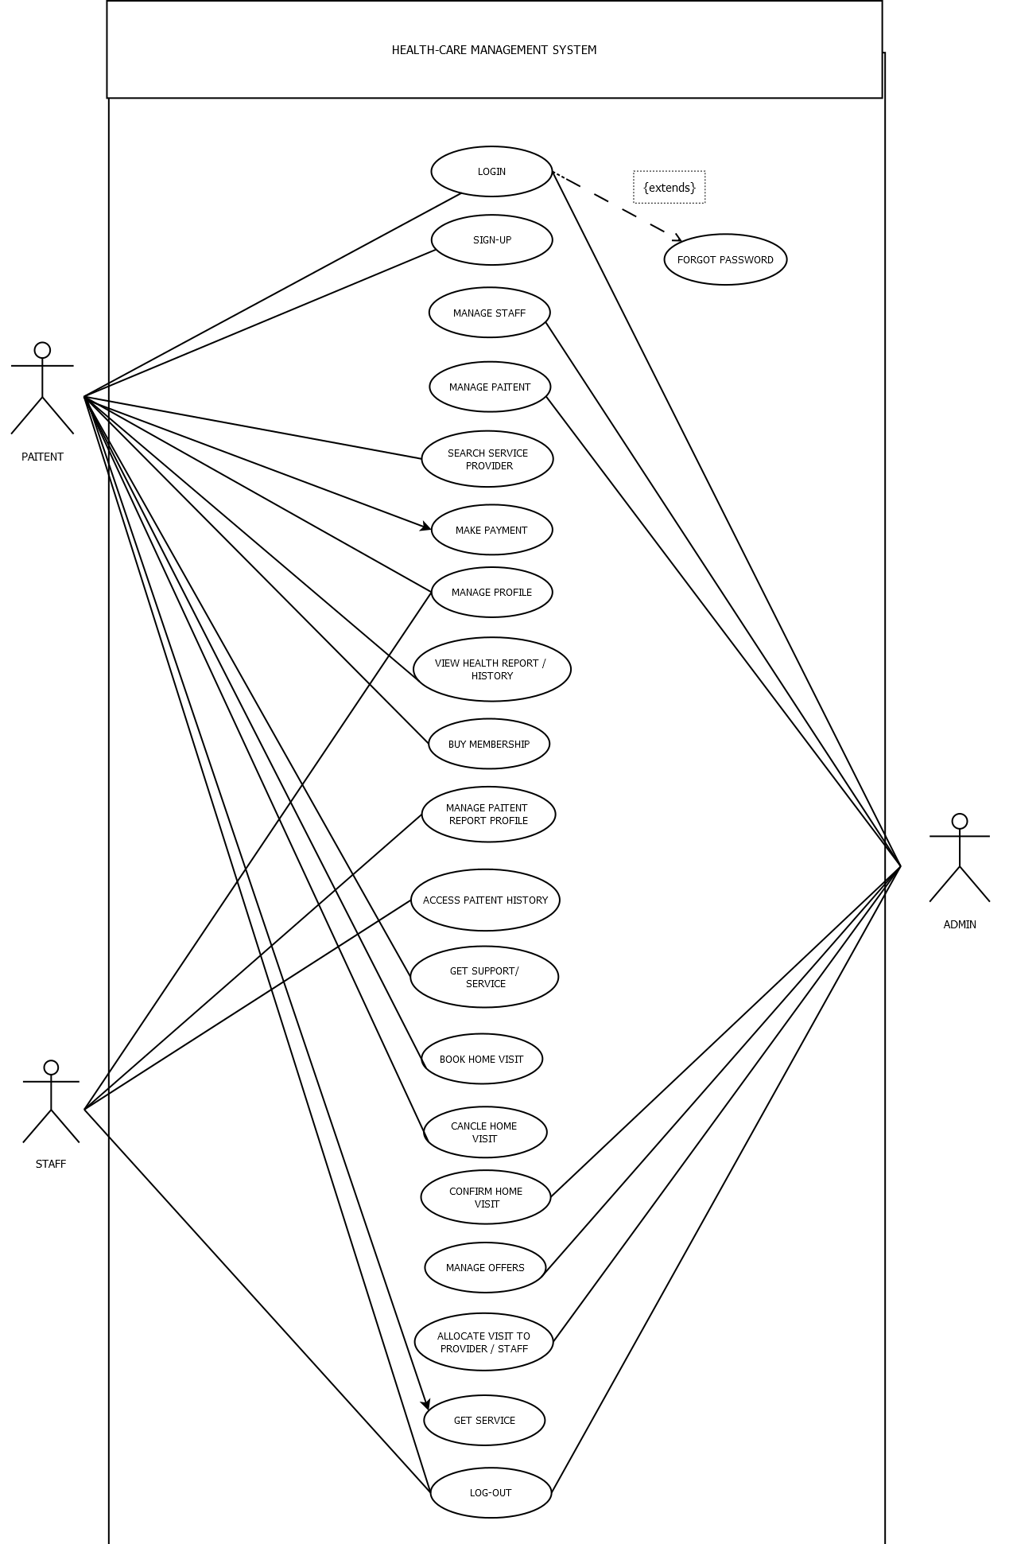

**3.2 Class Diagram**

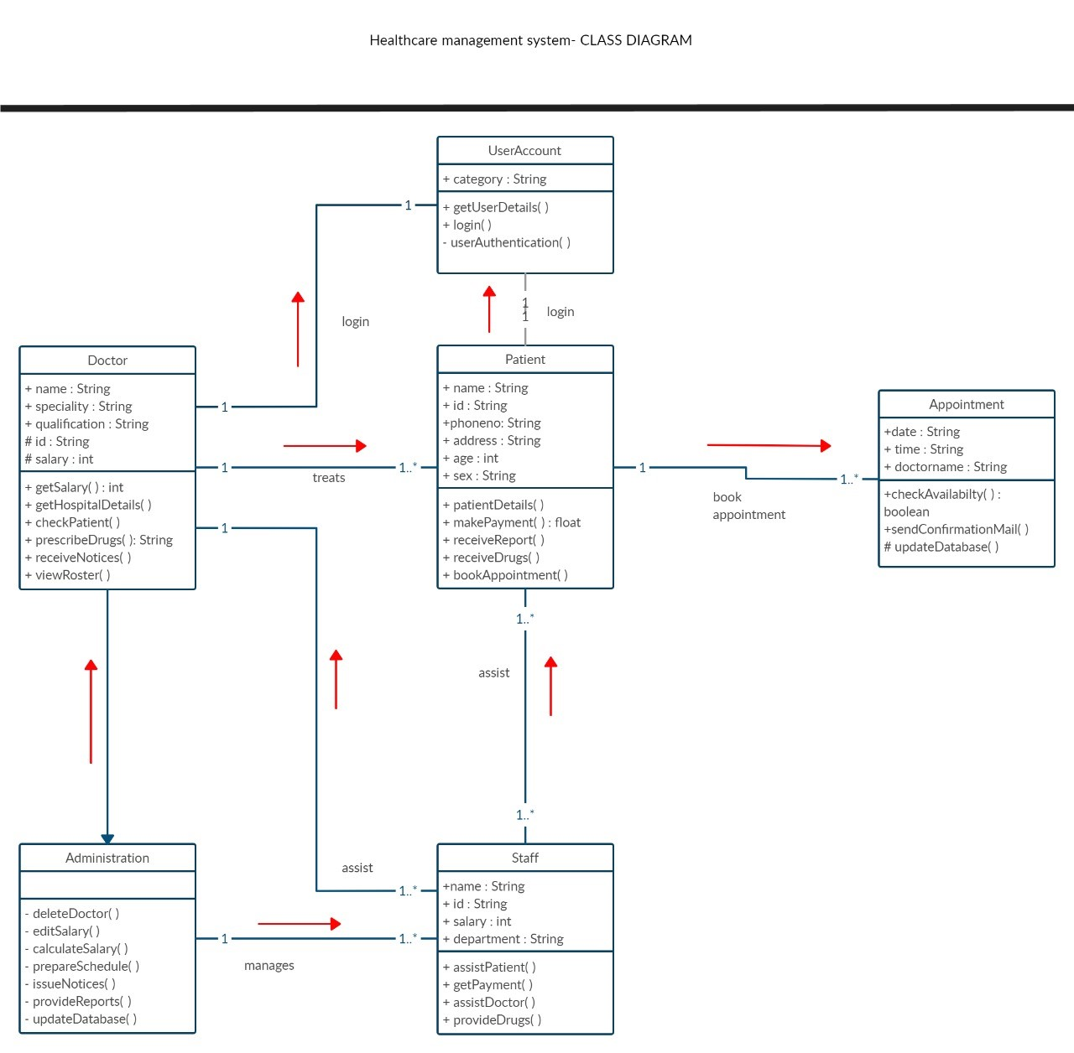

**3.4 Activity Diagram**

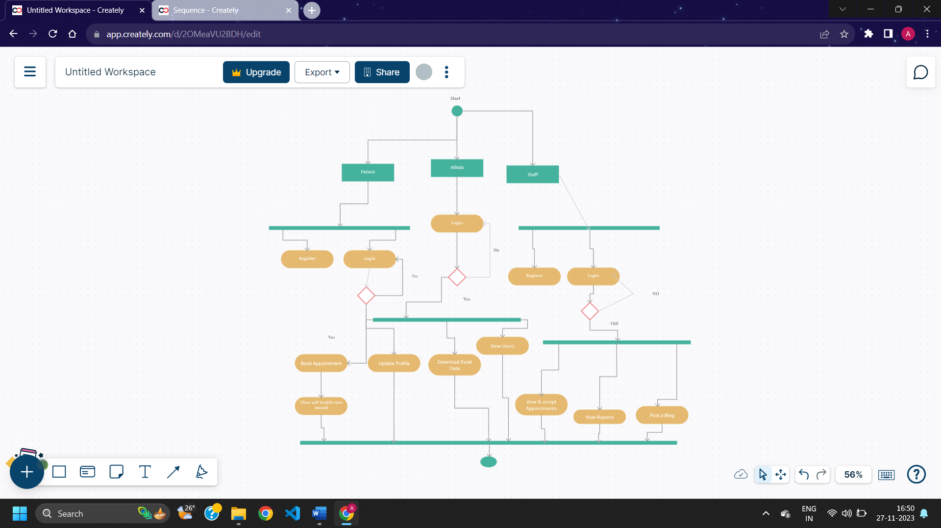

**3.5 Sequence diagram**

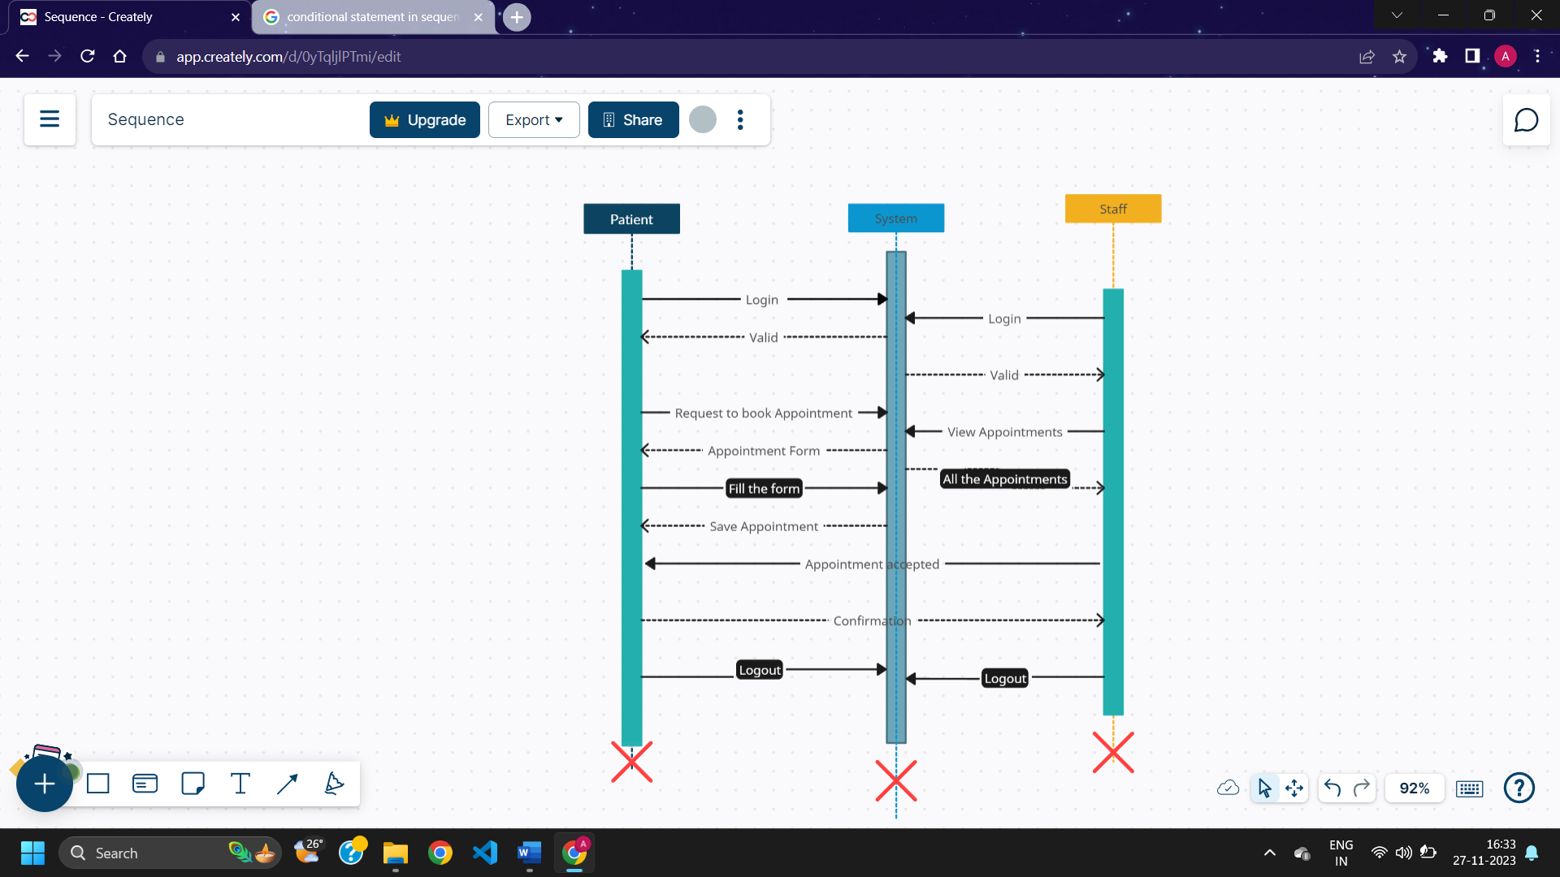

3.5 Data Dictionary

|  |  |  |  |  |
| --- | --- | --- | --- | --- |
| Field | Datatype | Constraints | Description | Sample |
| Id | Int(4) | primary key | Table id | 1 |
| First name | Varchar2(25) | Not null | Firstname of the user | Arnold |
| Last name | Varchar2(25) | Not null | Lastname of the user | Macwan |
| Email | Varchar2(25) | Unique | Email of the user | [abc@gmail.com](mailto:abc@gmail.com) |
| Password | Varchar2(10) | Not null | Password | abc@123 |
| DOB | Date | Not null | Date of birth | 20-03-1969 |
| Role | Varchar2(15) | Not null | Role of the user | Doctor |
| State | Varchar2(15) | Not null | State of user | Karnataka |
| City | Varchar2(15) | Not null | City of user | Pune |
| Pincode | Int(6) | Not null | Pincode of area | 382440 |
| Apartment | Varchar2(25) | Not null | Apartment no & name | B2 , harekrishna park |
| Userprofile | Varchar2(50) | Not null | Path of image of the user | pics/img.png |

**User table**

|  |  |  |  |  |
| --- | --- | --- | --- | --- |
| Field | Datatype | Constraints | Description | Sample |
| Id | Int(4) | primary key | Table id | 1 |
| resume | Varchar2(50) | Not null | Image path for Document of the qualification | doc/img.jpeg |
| Profilephoto | Varchar2(50) | Not null | Photo of the staff | pic/photo.png |
| Total_visit_done | Int(3) | Not null | No. of visit taken by staff | 12 |
| Experience | Int(3) | Not null | Experience of the staff | 25 years |
| Joined_date | date | Not null | Date of joining | 20-09-2002 |
| About | Varchar2(100) | Not null | About the staff | A supportive caretaker |
| Availability | Varchar2(10) | Not null | Status for staff Availability | Not available |

**Staff Profile table**

|  |  |  |  |  |
| --- | --- | --- | --- | --- |
| Field | Datatype | Constraints | Description | Sample |
| Id | Int(4) | primary key | Table id | 1 |
| Firstname | Varchar2 | Not null | First name of staff | John |
| Lastname | Varchar2 | Not null | Last name of staff | Smith |
| Email | Varchar2 | Unique | Email of staff | [abc@gmail.com](mailto:abc@gmail.com) |
| DOB | Date | Not null | Date of birth | 20-05-1996 |
| Category | Varchar2 | Not null | Category of staff | Care taker |

**Staff table**

|  |  |  |  |  |
| --- | --- | --- | --- | --- |
| Field | Datatype | Constraints | Description | Sample |
| Id | Int(4) | primary key | Table id | 1 |
| Staffid | Int(4) | Foreign key references staff table | Staff id | 11 |
| Name | Varchar2(25) | Not null | Title of the service | Lab test |
| Status | Varchar2(15) | Not null | Status of service | Pending |
| Cost | Decimal (4,2) | Not null | Cost of the service | 499/- |

**Service table**

**Test table**

|  |  |  |  |  |
| --- | --- | --- | --- | --- |
| Field | Datatype | Constraints | Description | Sample |
| Id | Int(4) | primary key | Table id | 1 |
| Category | Int(4) | Not null | Category of test | Full body |
| Cost | Decimal(4,2) | Not null | Cost for the service | 699 |
| Dur | Int(3) | Not null | Result duration in hours | 36 |

|  |  |  |  |  |
| --- | --- | --- | --- | --- |
| Field | Datatype | Constraints | Description | Sample |
| Id | Int(4) | primary key | Table id | 1 |
| Userid | Int(4) | Foreign key references user table | Id of the user | 2 |
| Date | Date | Not null | Date of the visit | 15-10-2023 |
| Status | Varchar2(10) | Not null | Status of the visit | Pending |
| Staffid | Int(4) | Foreign key references staff table | Visit allocate to the staff | 2 |
| Reason | Varchar2(25) | Not null | Reason for visit | Blood report |

**Appointment table**

**Billing table**

|  |  |  |  |  |
| --- | --- | --- | --- | --- |
| Field | Datatype | Constraints | Description | Sample |
| Id | Int(4) | primary key | Table id | 1 |
| Userid | Int(4) | Foreign key references user table | Id of the user | 2 |
| Date | Date | Not null | Date of the bill | 20-04-2024 |
| Discount | Decimal(6,2) | Not null | Discount price on bill | 2500/- |
| Total_amount | Decimal(6,2) | Not null | Amount of the bill | 9980/- |
| Payment_id | Int(10) | Foreign key references payment table | Payment id | 15002693 |

**Payment table**

|  |  |  |  |  |
| --- | --- | --- | --- | --- |
| Field | Datatype | Constraints | Description | Sample |
| Id | Int(4) | primary key | Table id | 1 |
| Userid | Int(4) | Foreign key references user table | Id of the user | 2 |
| Date | Date | Not null | Date of the payment | 20-04-2024 |
| Status | Varchar2(15) | Not null | Status of the payment | Pending |
| Payment_method | Varchar2(10) | Not null | Method of the payment | Cash |

|  |  |  |  |  |
| --- | --- | --- | --- | --- |
| Field | Datatype | Constraints | Description | Sample |
| Id | Int(4) | primary key | Table id | 1 |
| Userid | Int(4) | Foreign key references user table | Id of the user | 2 |
| Date | Date | Not null | Date of the feedback received | 20-04-2024 |
| Message | Varchar2(250) | Not null | Message for feedback | It was good |

**Feedback table**

**Blog table**

|  |  |  |  |  |
| --- | --- | --- | --- | --- |
| Field | Datatype | Constraints | Description | Sample |
| Id | Int(4) | primary key | Table id | 1 |
| Userid | Int(4) | Foreign key references user table | Id of the user | 2 |
| Date | Date | Not null | Date of the feedback received | 20-04-2024 |
| Message | Varchar2(250) | Not null | Message description | It was good |

4. Development

4.1. Coding standard

* **Project structure:**
* Use clear and descriptive names for the whole directory of the project and also recommend the naming conventions rules for the variables and functions names.
* **Code-version management:**
  + Use a version control system (i.e., GitHub) for the project to collaborate effectively.
* **UI design:**
  + Design a user-friendly interface so that user can use the system and understand it easily.
* **Error handling:**
  + Implement an error free code and use error handling mechanism for user interactions.
* **Further development:**
  + Maintain the system as well conduct regular reviews that genuine feedback for the system.
  + Always look for the further improvement of the system that can make the system work more accurate and reliable

4.2. Screenshots

* Login screen

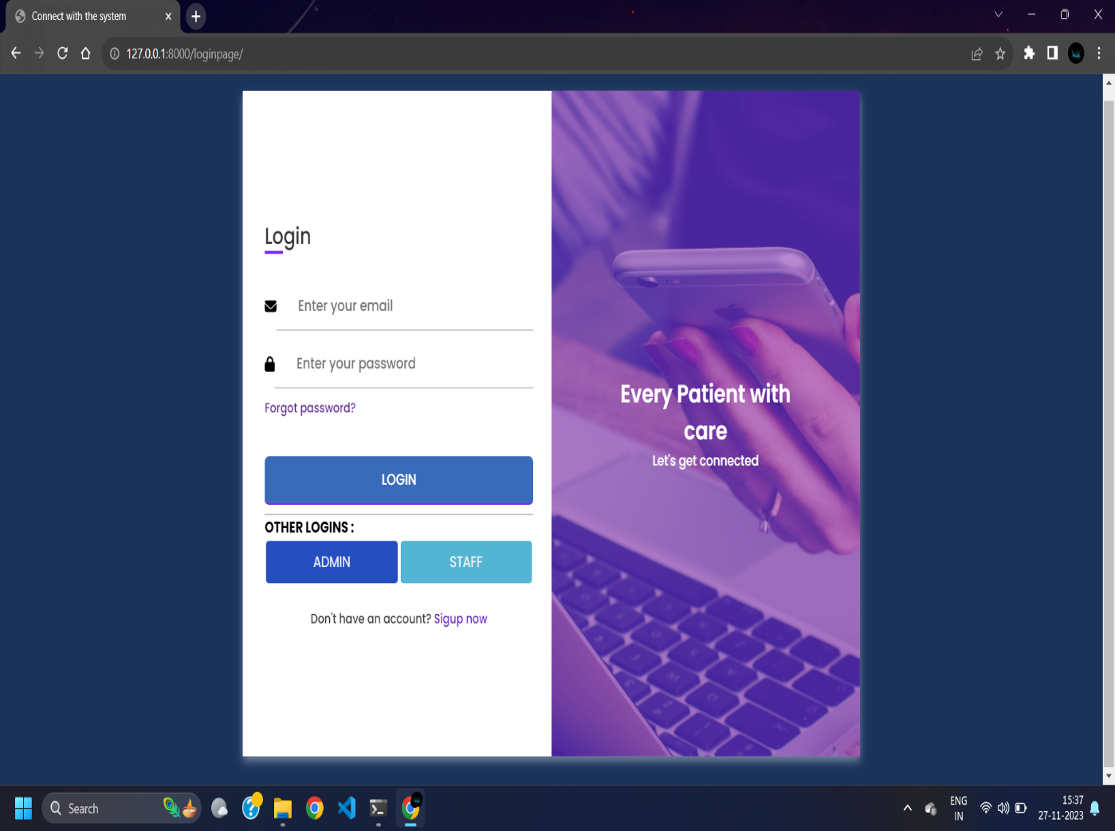

* Home screen

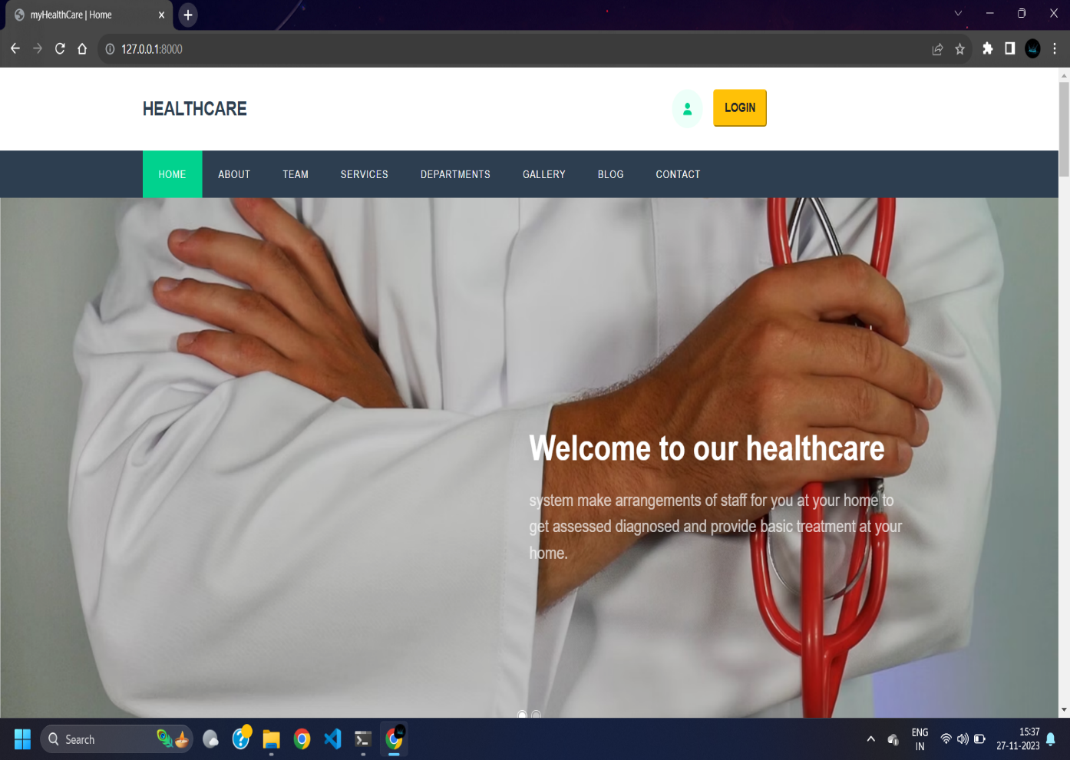

* Staff Registration

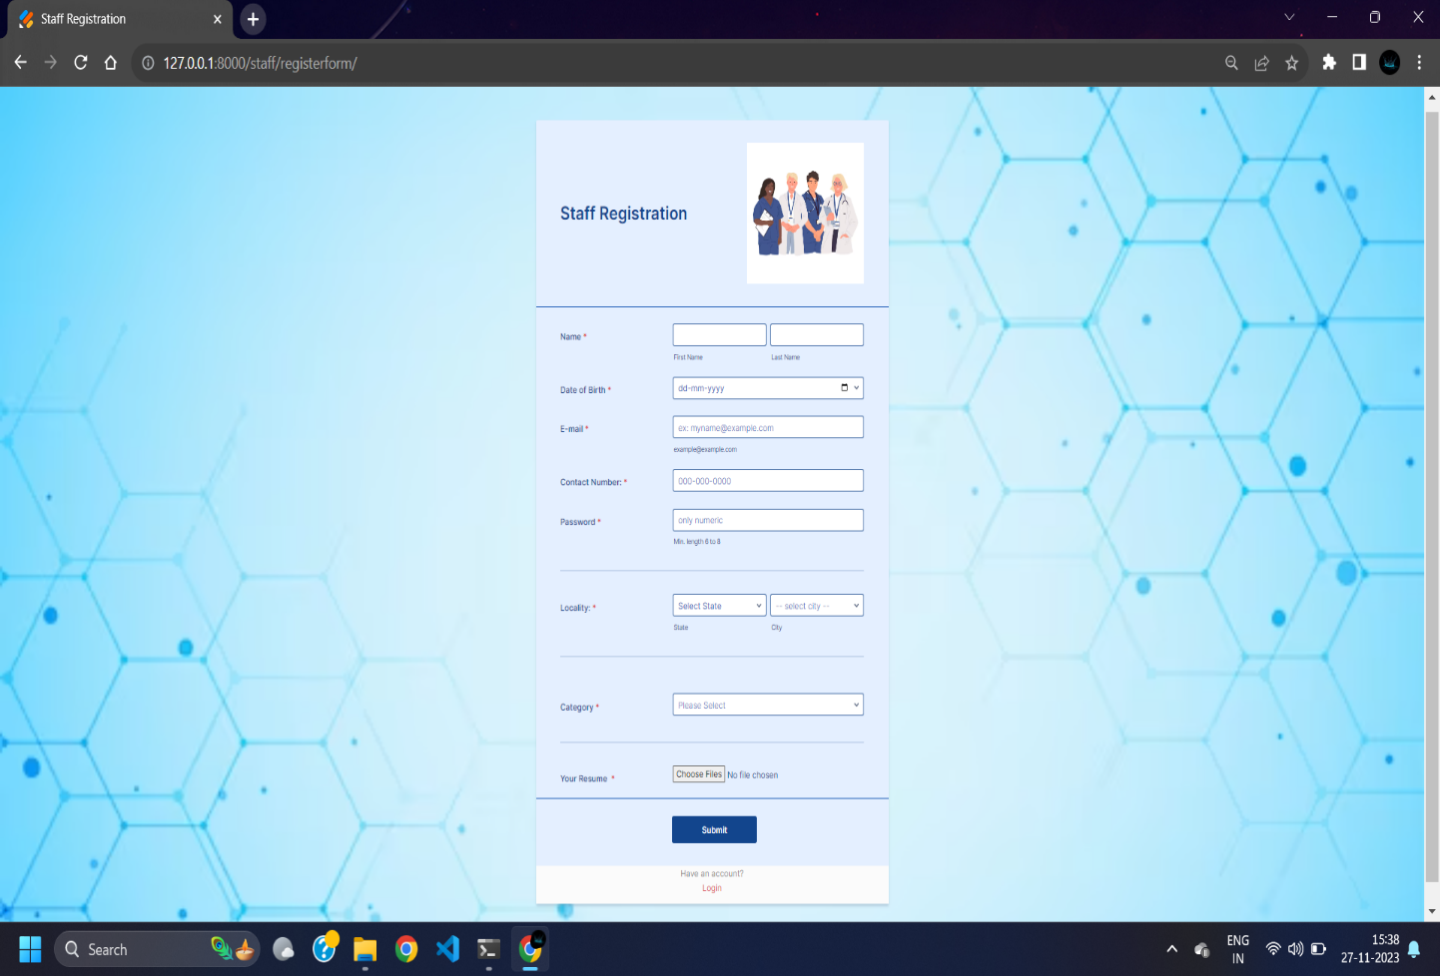

* Book Appointment

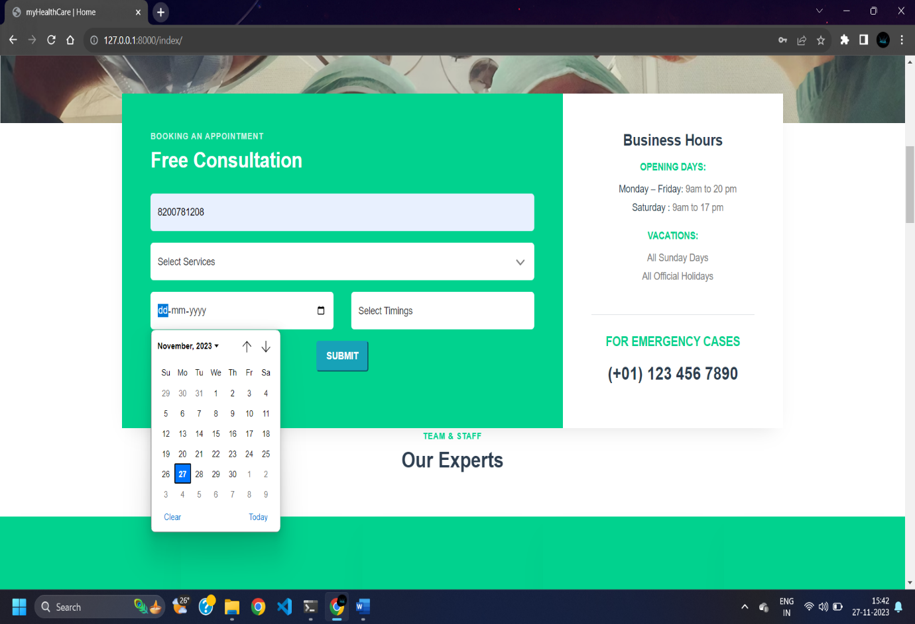

* User Profile

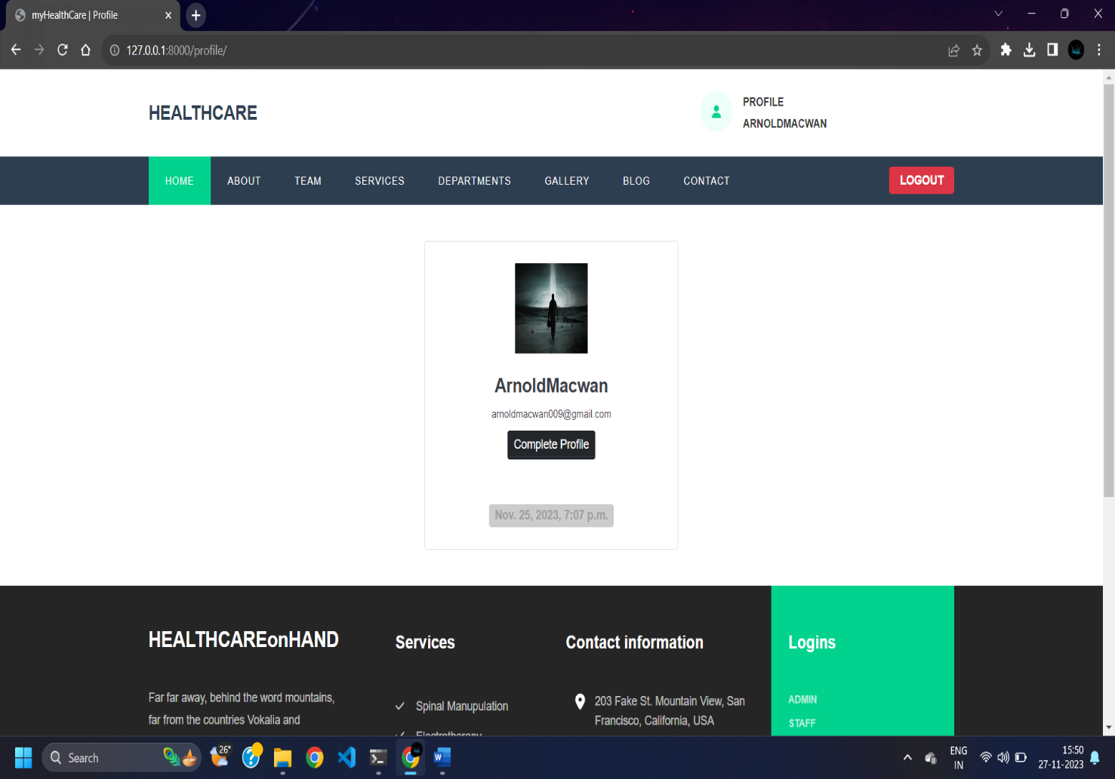

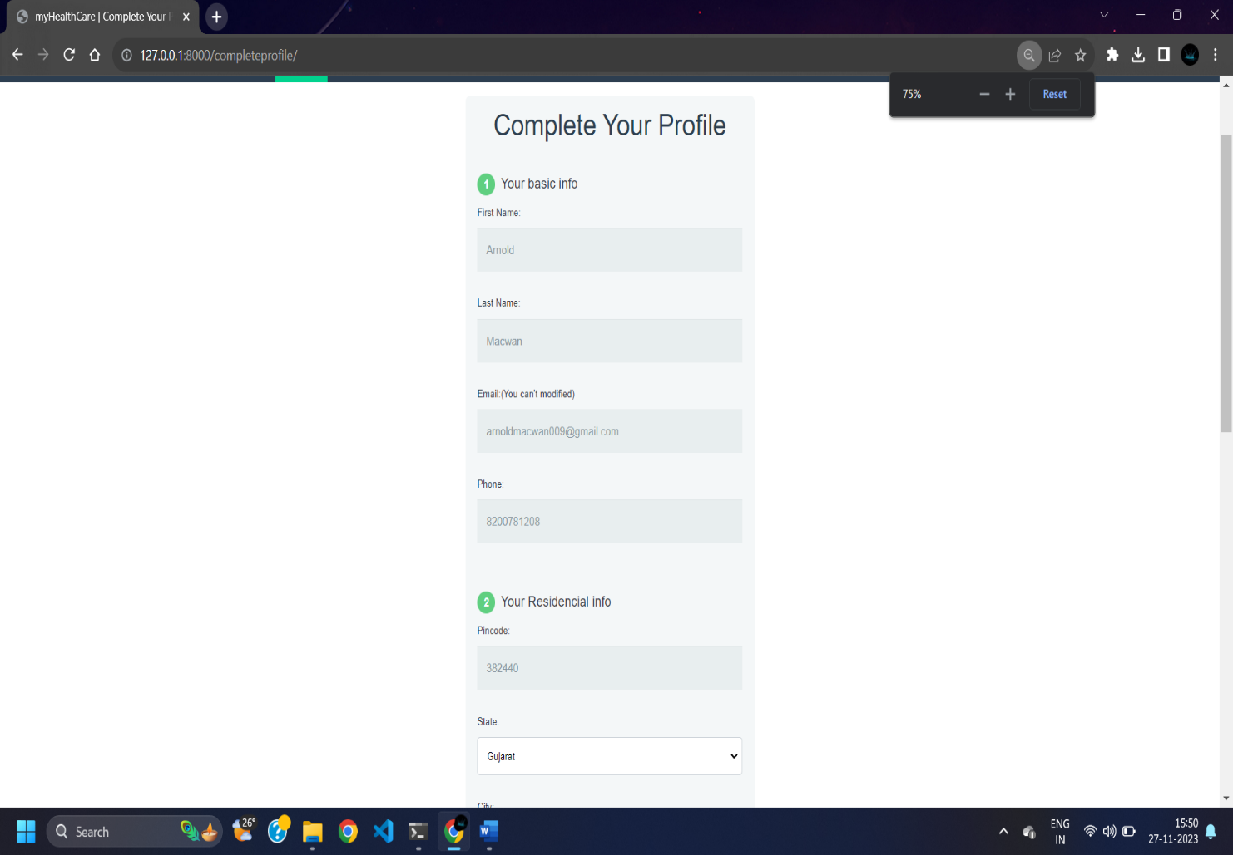

* Manage Lab Test

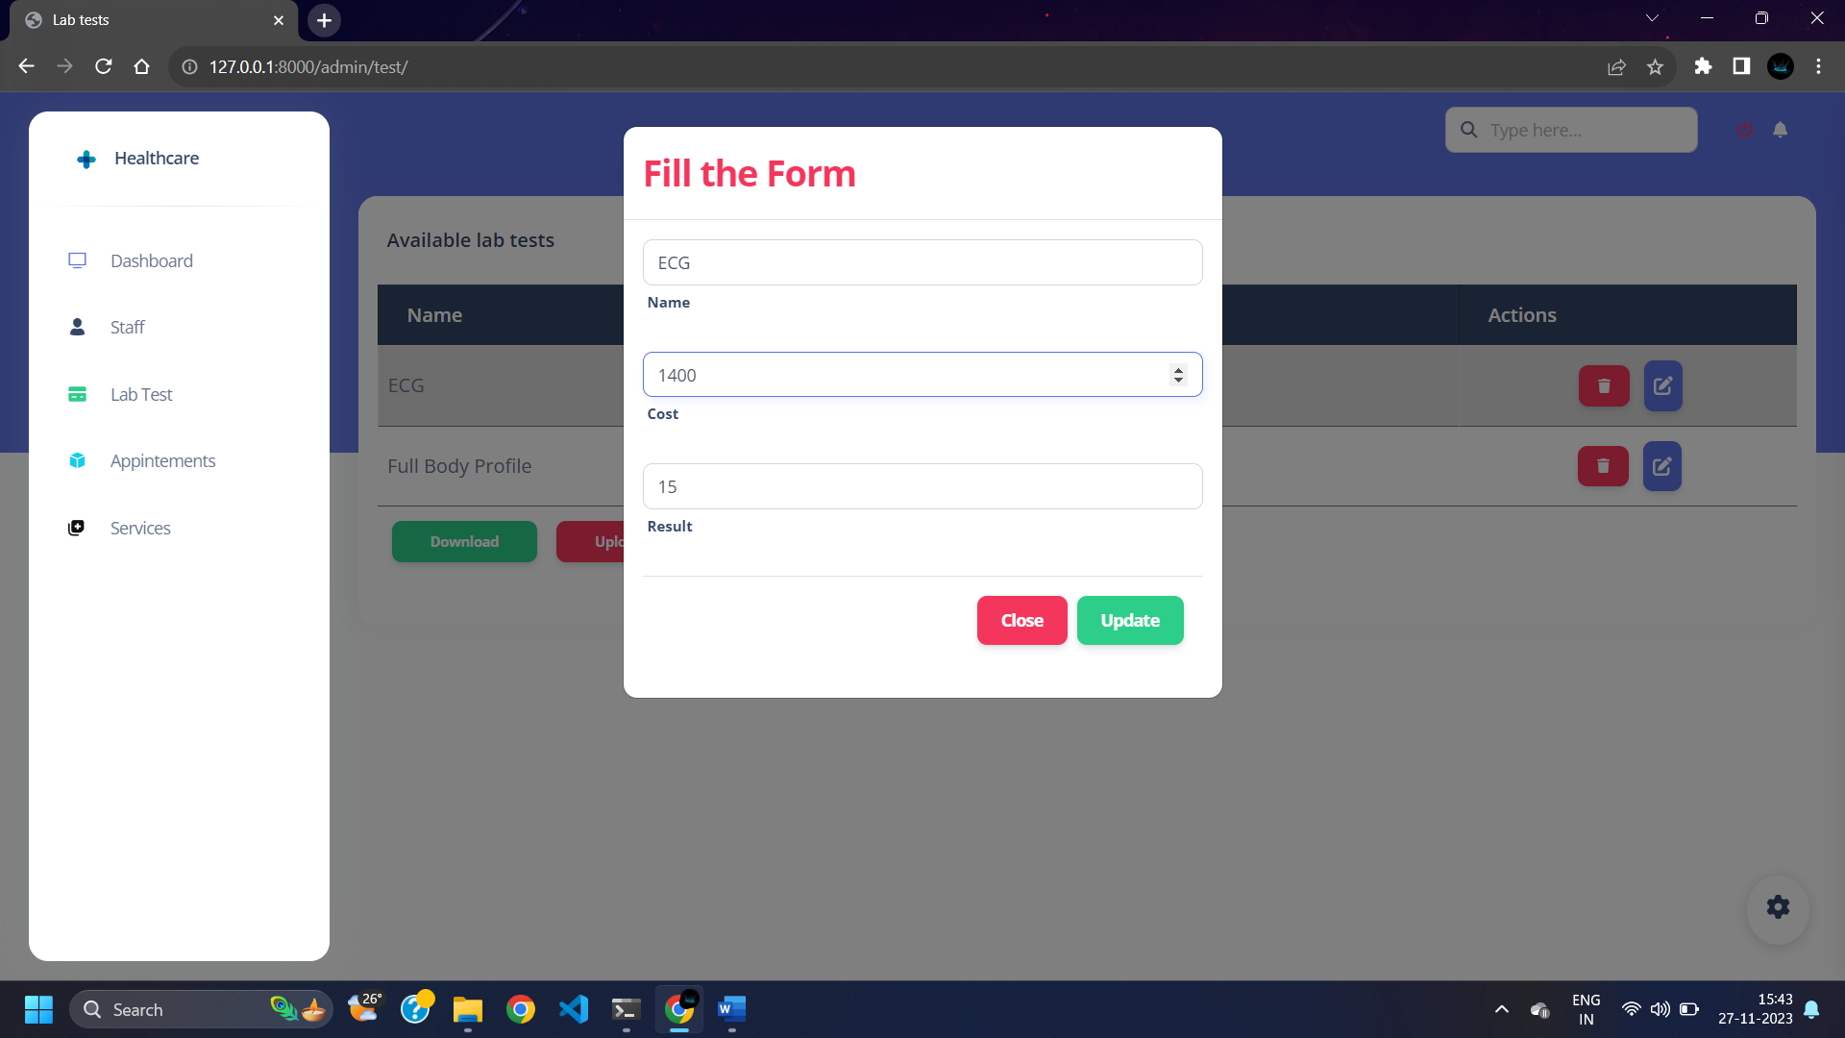

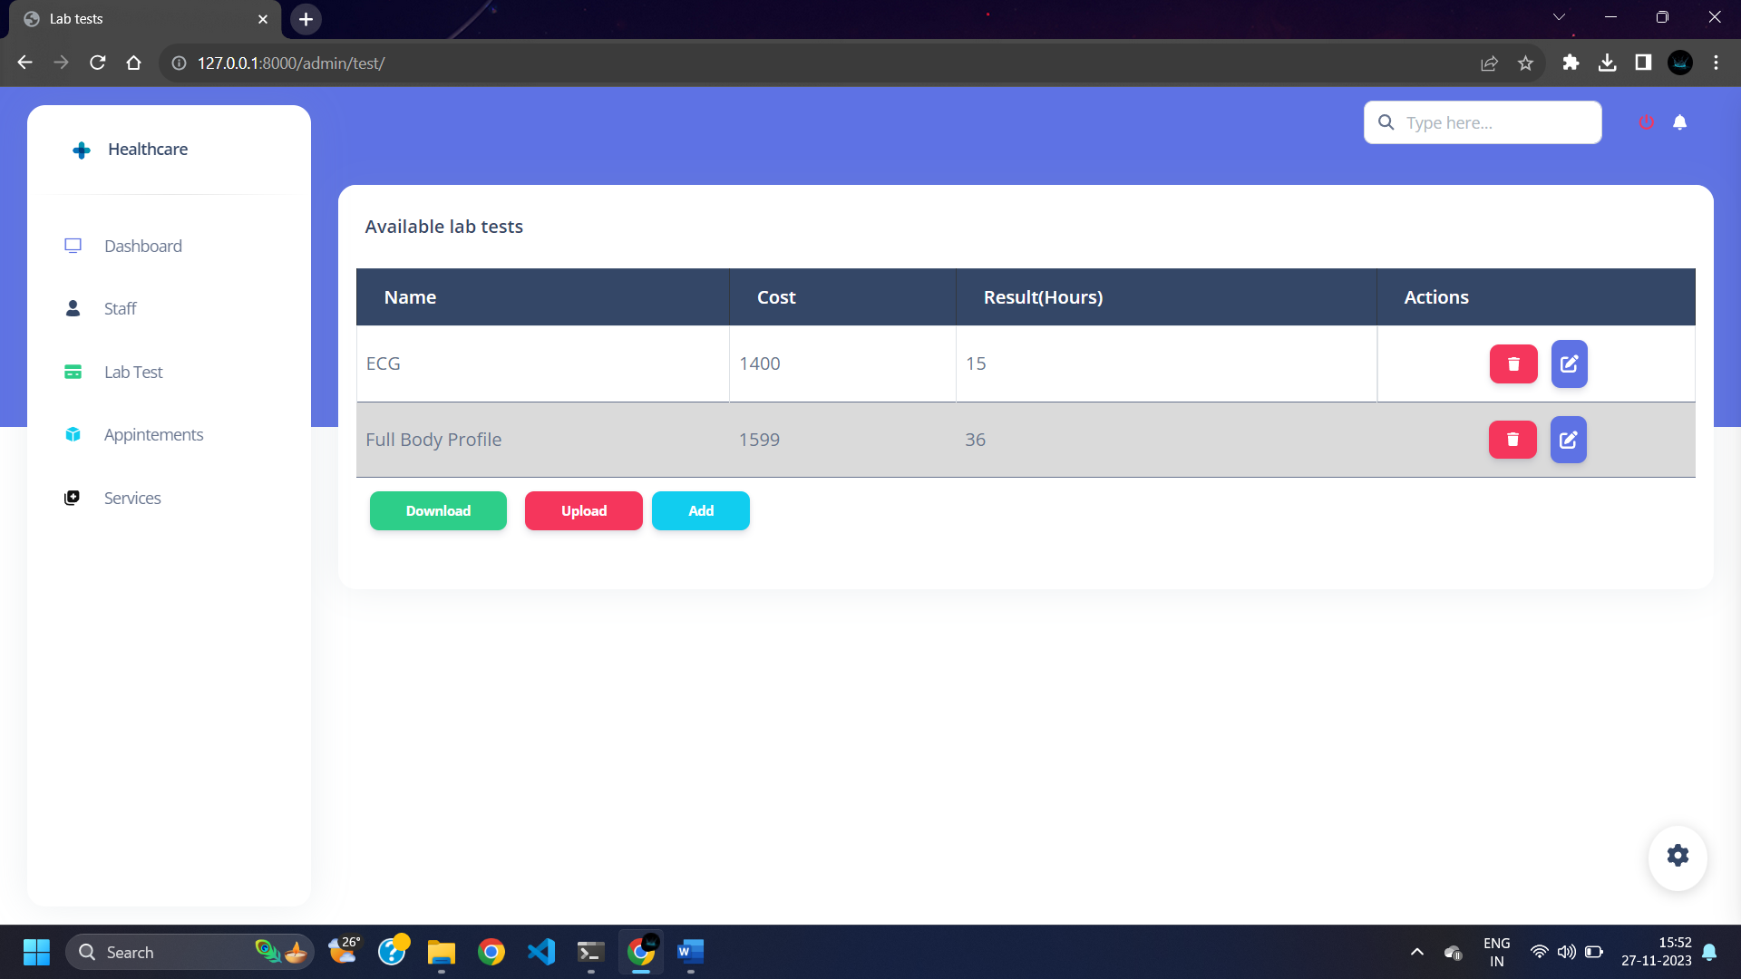

* Password reset via email verification

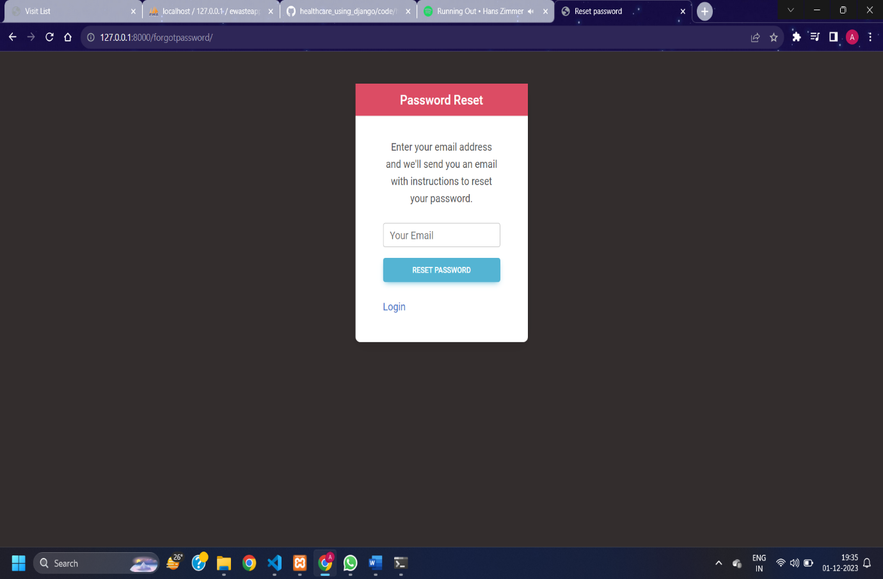

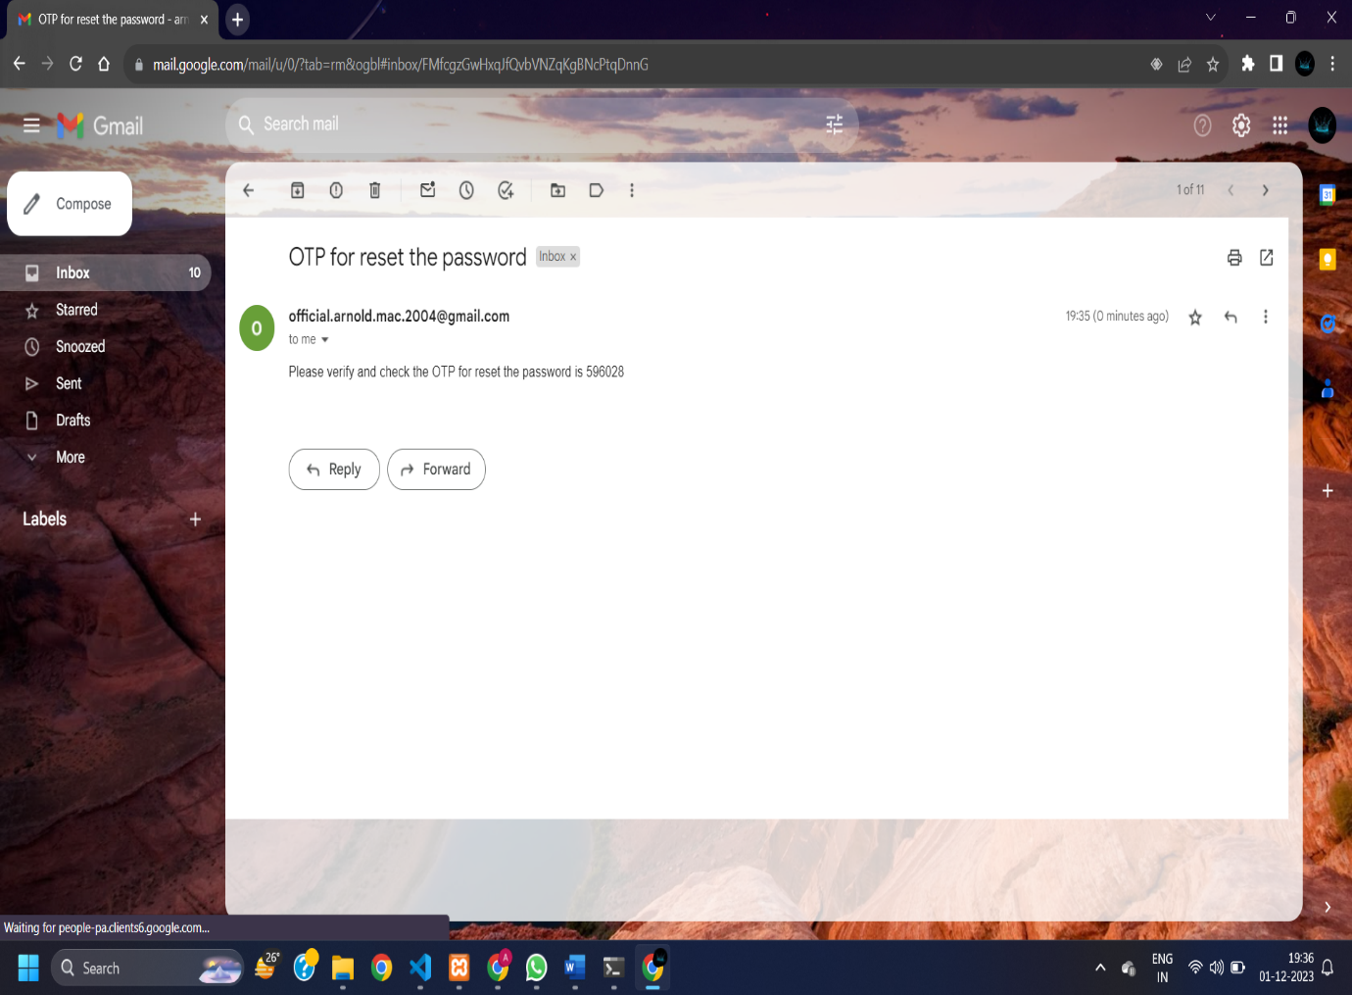

* Download Excel file

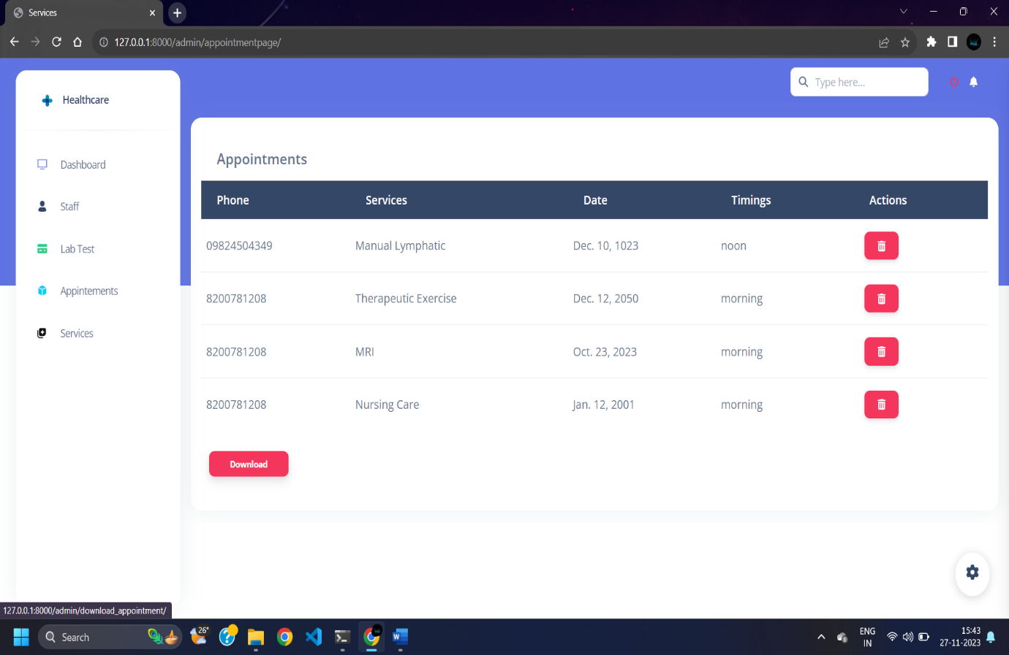

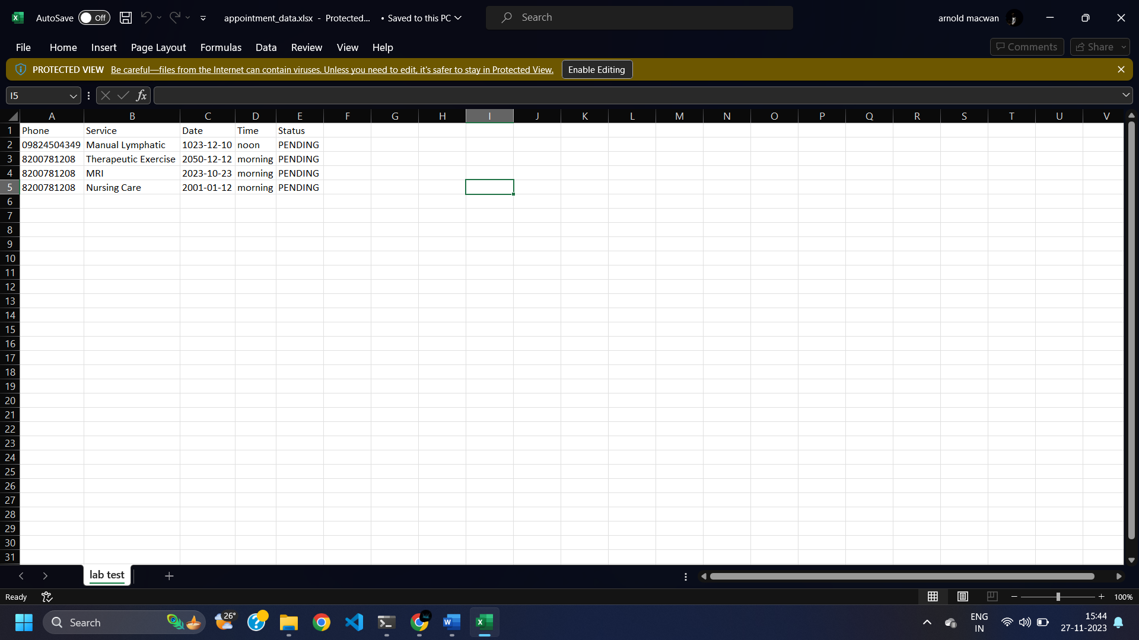

AGILE DOCUMENTATION

|  |  |
| --- | --- |
| **Project name** | Healthcare web Application |
| **Guide** | Dr Jignesh Doshi |
| **Project expected start date** | 14-08-2023 |
| **Project expected end date** | 30-11-2023 |
| **Project Scope** | * Integration of Booking health service * Custom Admin UI deployment * Report and documentation download * Safe & secure storing patient information and medical history |
| **Project mission** | Our mission is to provide such a platform so that every customer using the system will get the enhanced online service for their health accordingly their customization. |
| **Project vision** | Our vision is to reach every person who is not able to take even primary healthcare services and provide them services at doorstep by using their phones. |

1. **Project charter**
2. **Project Roadmap**

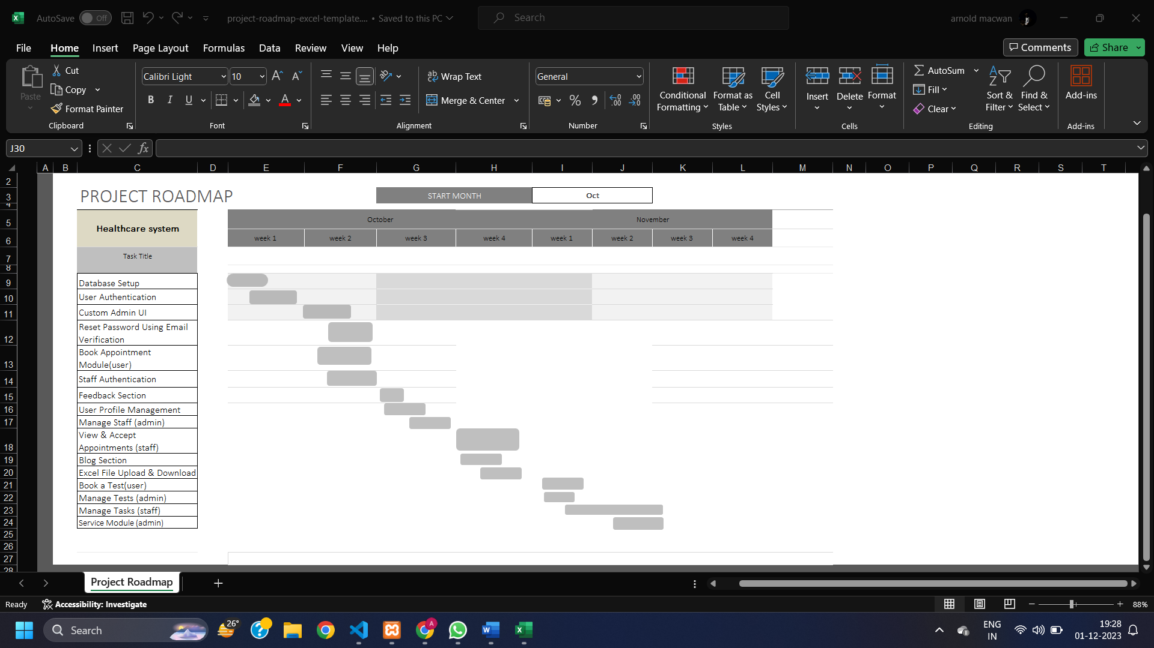

|  |  |  |  |  |  |
| --- | --- | --- | --- | --- | --- |
| **Id #** | **Task / Module** | **Assigned to** | **Status** | **Estimated time(hours)** | **Story points** |
| 1 | Authentication | Arnold | Completed | 3 | 6 |
| 2 | Password Reset & verification | Arnold | Completed | 2 | 4 |
| 3 | Appointment Module | Dharmik | Completed | 8 | 10 |
| 4 | Service Module | Dharmik | Completed | 6 | 8 |
| 5 | Test Module | Arnold | Completed | 2 | 4 |
| 6 | Profile management | Tirth | Completed | 4 | 8 |
| 7 | Download Data Files | Tirth | Completed | 4 | 8 |
| 8 | Book Home Visit | Arnold | Completed | 2 | 4 |
| 9 | Manage Tasks (staff) | Arnold | Completed | 8 | 10 |
| 10 | Blog Section | Tirth | Completed | 3 | 6 |
| 11 | Feedback Section | Dharmik | Completed | 3 | 6 |

1. **Sprint table**
2. **User Story**

|  |  |  |  |
| --- | --- | --- | --- |
| Sr. | As a <user> | Want to <task> | So that <goal> |
| 1 | Admin | Login | I can manage flow and activities as administrator |
| 2 | Admin | Manage users / patient | I can control user activities & account related issues |
| 3 | Admin | Manage staff | I can control & review staff activities |
| 4 | Admin | Confirm home-visit request | I can verify & accept user’s request for home visit |
| 5 | Admin | Allocate service to staff | Staff can handle service for patient |
| 6 | Admin | Manage lab test | Let the Lab tester know about it & patients can use |
| 7 | Admin | Manage services | User can request for service provider accordingly |
| 8 | Admin | Post a blog | Article & blogs can be read |
| 9 | Admin | Logout | No one can access system except me |
| 10 | Patient | Login | I can use the system as existing user |
| 11 | Patient | Sign up | I can use the system as new user |
| 12 | Patient | Manage profile | I can edit or delete my profile account & review profile |
| 13 | Patient | Buy premium | I can use extra benefits of system |
| 14 | Patient | Browse services | I can search & view services accordingly |

|  |  |  |  |
| --- | --- | --- | --- |
| Sr. | As a <user> | I Want to <task> | So that <goal> |
| 15 | Patient | Give feedback | I can give feedback of system & enhancement can be done |
| 16 | Patient | Request home visit | I can book a home visit |
| 17 | Patient | View medical history | I can review health report & history |
| 18 | Patient | Get service | I can book service according to need |
| 19 | Patient | Cancel home visit | I can remove appointment for home visit If it isn’t needed |
| 20 | Patient | Subscribe newsletter | I can quickly get update of new news & events |
| 21 | Patient | Logout | No one can access my data |
| 22 | Staff | Sign up | I can join system as service provider |
| 23 | Staff | Login | I can use system as existing user |
| 24 | Staff | Manage profile | I can edit or remove personal profile from system |
| 25 | Staff | Access patient medical history | I can provide service accordingly |
| 26 | Staff | Update Availability | I can take leave accordingly |
| 27 | Staff | Manage tasks/appointments | I can review or update all pending tasks allocated |
| 28 | Staff | Delete account | I can remove myself as a service provider from system |
| 29 | Staff | Logout | No one can access my data |

1. **Release plan**

|  |  |  |  |  |
| --- | --- | --- | --- | --- |
| **Task** | **Start date** | **End date** | **Status** | **Release date** |
| Database connection & setup | 02-10-2023 | 03-10-2023 | Released | 04-10-2023 |
| User authentication | 04-10-2023 | 06-10-2023 | Released | 06-10-2023 |
| Custom Admin UI | 08-10-2023 | 10-10-2023 | Released | 11-10-2023 |
| Reset password with email | 11-10-2023 | 12-10-2023 | Released | 13-10-2023 |
| Book Appointment module (user) | 12-10-2023 | 13-10-2023 | Released | 13-10-2023 |
| Staff Authentication | 15-10-2023 | 17-10-2023 | Released | 19-10-2023 |
| Feedback section | 16-10-2023 | 17-10-2023 | Released | 17-10-2023 |
| User Profile  Management | 16-10-2023 | 18-10-2023 | Released | 19-10-2023 |
| Book Home Visit | 23-10-2023 | 26-10-2023 | Released | 26-10-2023 |
| Manage Tasks (staff) | 03-11-2023 | 08-11-2023 | Released | 08-11-2023 |
| Manage Tests | 05-11-2023 | 08-11-2023 | Released | 09-11-2023 |
| Service Module | 06-11-2023 | 09-11-2023 | Released | 10-11-2023 |

1. **Test Plan**

|  |  |  |  |
| --- | --- | --- | --- |
| Project Name | Healthcare System | Browser: | Chrome |
| Tested on: | 30-11-2023 | Device: | Ryzen 5 Laptop |

|  |  |  |  |  |
| --- | --- | --- | --- | --- |
| Test# | Action | Expected Result | Actual Result | Status |
| 1 | User Authentication | Redirect to home screen | Redirect to home screen | Pass |
| 2 | Staff Authentication | Redirect to staff home screen | Redirect to staff home screen | Pass |
| 3 | Admin Authentication | Redirect to admin screen | Redirect to admin screen | Pass |
| 4 | Reset password using Email | Password reset by sending email | Password reset by sending email | Pass |
| 5 | Feedback section | Feedbacks should be displayed on user screen | Feedbacks is displayed on user screen | Pass |
| 6 | Book Appointment | Appointment should be booked | Appointment is booked | Pass |
| 7 | View and accept Appointment (staff) | Appointment should be view and manage by staff | Appointment is viewed and getting manage | PASS |
| 8 | Edit Profile (user) | Profile should be Update | Profile is being updated | Pass |
| 9 | Blog Section | Blogs Should be posted and displayed | Blogs are being posted but not getting read | FAIL |
| 10 | Service Module | Service can be booked and viewed | It’s working Good | PASS |
| 11 | Manage Tasks | Tasks can be managed by staff | Tasks are getting managed | PASS |

1. **Sprint Burn Chart**

**Proposed Enhancements**

* System is focusing on resolving current issues and enhancing functionality.
* Improvements include data security, efficient analytics using machine learning, and integrating telemedicine.
* Access control and advanced encryption techniques can protect patient data.
* System is also looking for mobile applications which can help monitor patients remotely and communicate with them in real time.

**Conclusion**

* A healthcare management system is essential for improving patient care, operational effectiveness, data security, and regulatory compliance. It promotes the implementation of cutting-edge technologies, facilitates the seamless sharing of patient data, and helps with cost management.

**Bibliography**

* + - https://www.indimac.in/
    - https://www.advinohealthcare.com/